Chapter 10, Problem 89.

The op amp circuit in Fig. 10.131 is called an inductance simulator. Show that the input impedance is given by,

Z_{in} = V_{in}/I_{in} = jωL_{eq}

where

L_{eq} = [(R₁R₃R₄)/R₂]C.
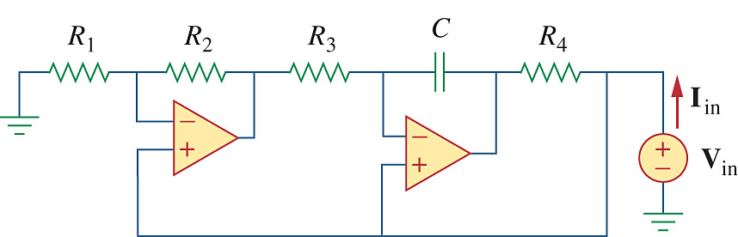

Figure 10.131
For Prob. 10.89.

